**Westpac Practical Assessment Test**

**Steps:**

1)From Github clone the repo or download the zip file and add to solution

2)Attaching two solutions



a) **KiwiSaverCalcBase** : It is a generic solution which can be plug in to any of the application. For Assertions,selenium methods a wrapper written on top of it, as hybrid framework.

Which can be easily compatible with our project terminology rather than using standard selenium method names and error.

From this application we are only taking KiwiSaverCalcBase.dll, as this is a base/common functionality, no one can edit or change any params or methods.

Navigate to respective folder: C:\Users\admin\Desktop\PraveenKiran_Westpac_ Assessment\KiwiSaverCalcBase\KiwiSaverCalcBase\bin

1)Copy KiwiSaverCalBase.dll

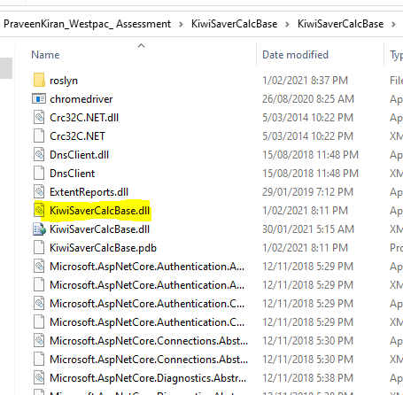

2)Create a folder **DLL** in D drive and Paste the KiwiSaverCalcBase.dll , to refer this dll to our solution. The same steps can be performed to any of the application to use common functionality.

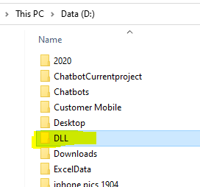

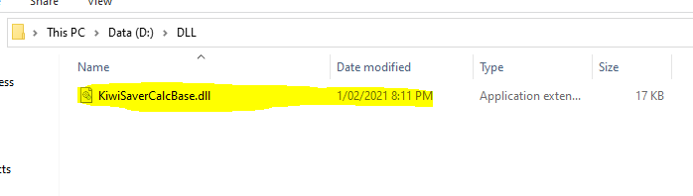

b) KiwiSaverTest: In this solution, we are referring the KiwiSaverCalcBase.dll and we are using data driven testing with nUnit framework.

3)Adding .dll: On right clicking on Reference a small window with Add Reference will slide,select Add reference.

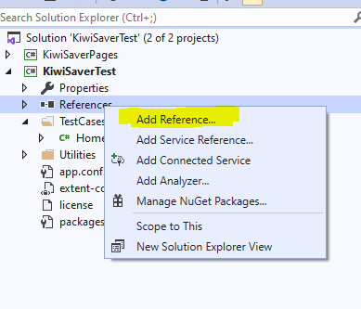

4)Click on browse button

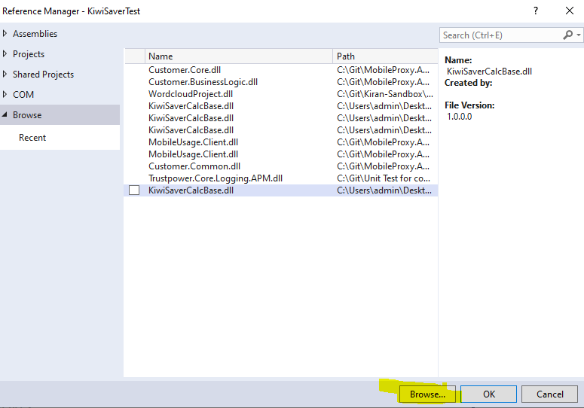

5)Navigate to already created folder(DLL) in D drive: D:\DLL(ref Step 2)

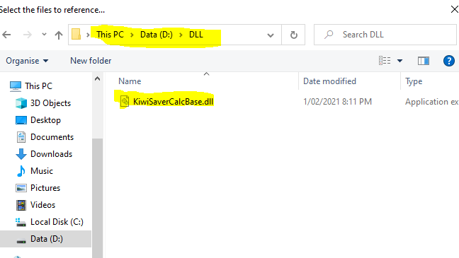

6)Select the DLL and click on Add button

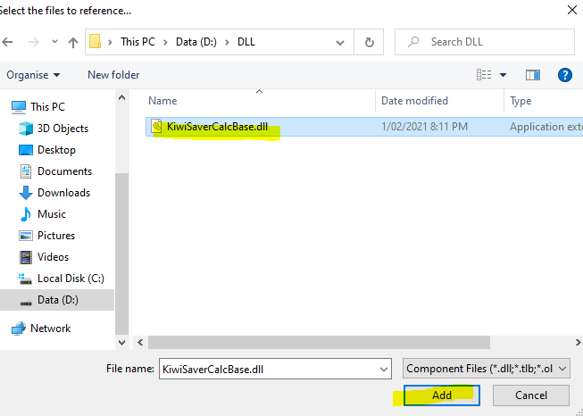

7)We can see the DLL in the Reference Manager, Click on OK button, it will add to solution.

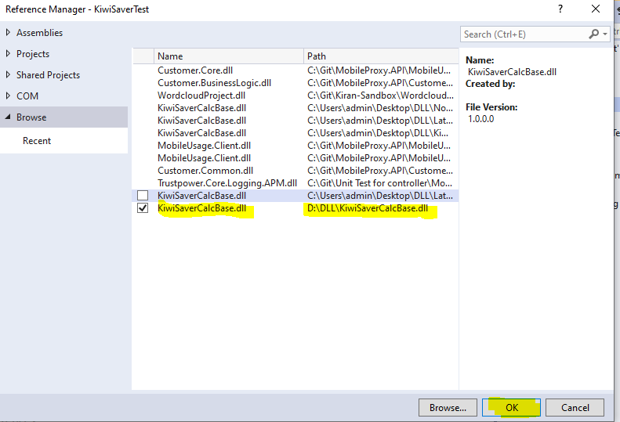

8)The same steps should perform for both KiwiSaverPages and KiwiSaverTest, which are mandatory

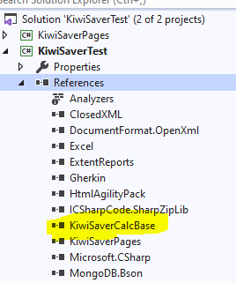

As KiwiSaverTest points to the outerworld and KiwiSaverpages are backend to it.

9)Adding KiwiSaverPages reference to KiwisaverTest.

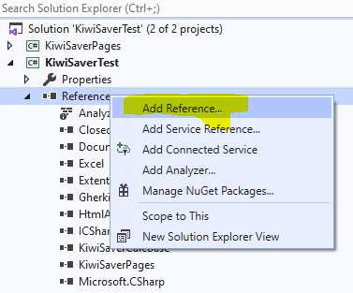

10)This time we are selecting option Projects from Reference Manager -> solutions we can see KiwiSaverPages project, please check the check button and click Ok below it.

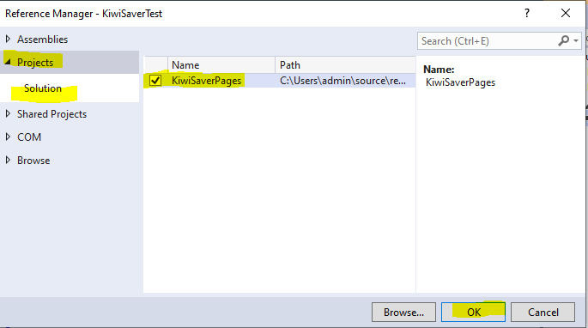

11)Pages added to Test

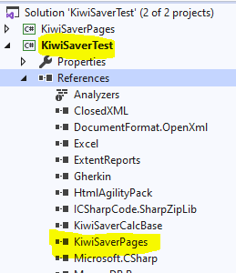

12)DataDrivenTesting: As part of DDT We are using Excel sheet to read the data. Created a folder in D drive with an excel sheet with Data, attaching the same file. Please copy paste in same location with same folder structure and name.

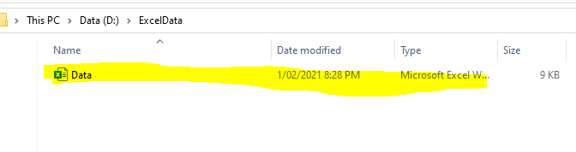

**Checkpoint:**

1)We have copied KiwiSaverCalBase.dll from KiwiSaverCalcBase common solution to folder DLL in D drive.

2)Added KiwiSaverCalcBase.dll to KiwiSaverTest->KiwiSaverPages & KiwiSaverTest by using Add reference.

3)Added KiwiSaverPages reference to KiwisaverTest by using Add Reference -> Projects.

4)Created a folder in D drive as ExcelData and copy pasted the Data.xlsx sheet.

Now we are ready to execute the test cases in Test Explorer.

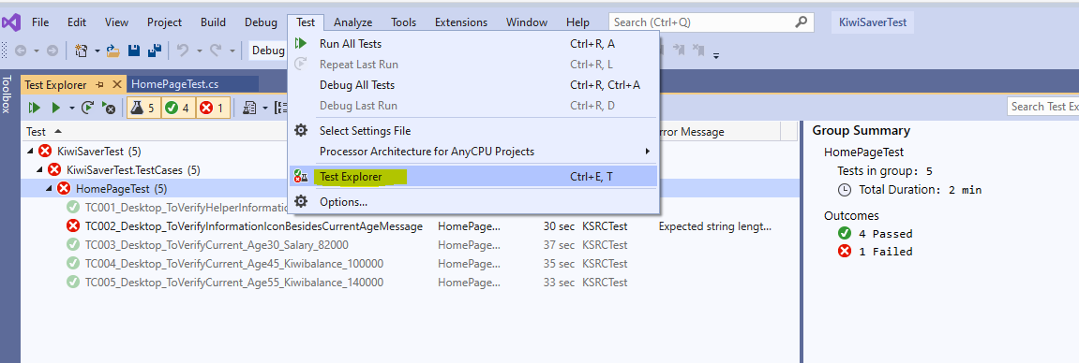

Once you execute complete Tests 4/5 cases are executed successfully. One test case failed since the text is not matching

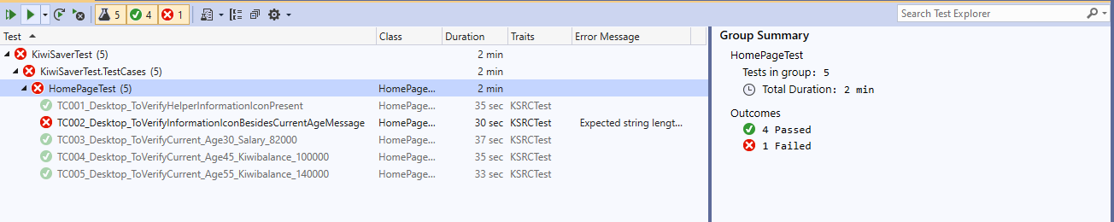

Folder structure:

**KiwiSaverCalcBase**

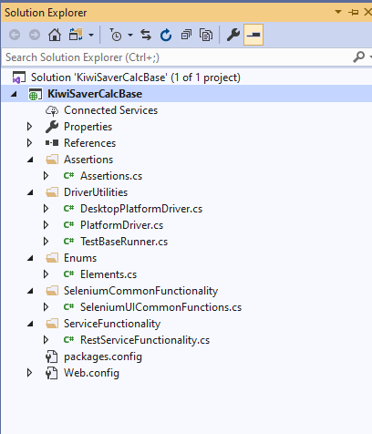

**KiwiSaverTest**

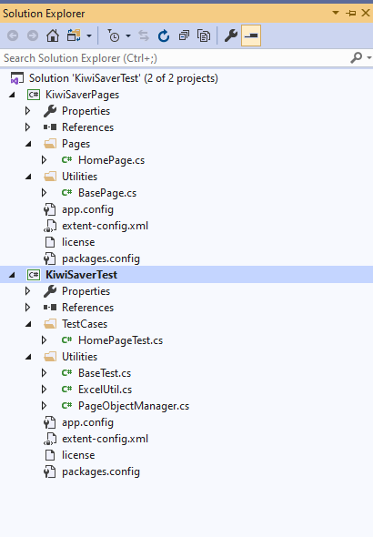

**App.config for website url:**

<appSettings>

<add key="EndPoint" value="westpac.co.nz" />

<add key="IsLocal" value="#{IsLocal}#" />

<add key="ApplicationUrl" value="http://{0}#{ApplicationUrl}#" />

<add key="BasicUserNamePassword" value="#{BasicUserName:BasicPassword}#" />

<add key="AdminUserNamePassword" value="#{AdminUserName:AdminPassword}#" />

</appSettings>

For any queries or concerns feel free to contact me, I am happy to help. Please reach out to me by email: [praveenchukkala07@gmail.com](mailto:praveenchukkala07@gmail.com)